# Worksheet 3b Functions

**Mars Probe Lost Due To Simple Math Error**

NASA lost its $125-million Mars Climate Orbiter because spacecraft engineers failed to convert from English to metric measurements when exchanging vital data before the craft was launched, space agency officials said Thursday.

A navigation team at the Jet Propulsion Laboratory used the metric system of millimeters and meters in its calculations, while Lockheed Martin Astronautics in Denver, which designed and built the spacecraft, provided crucial acceleration data in the English system of inches, feet and pounds.

As a result, JPL engineers mistook acceleration readings measured in English units of pound-seconds for a metric measure of force called newton-seconds.

In a sense, the spacecraft was lost in translation.

"That is so dumb," said John Logsdon, director of George Washington University's space policy institute.

*Source: R Hotz, LA Times (http://articles.latimes.com/1999/oct/01/news/mn-17288)*

1. **Conversion Table**

Use the conversion table to create a range of functions.

Each function should complete one possible conversion.

|  |  |
| --- | --- |
| **One** | **Equals** |
| 1 inch | 2.54 cm |
| 1 mile | 1.6093 km |
| 1 foot | 0.3048 m |
| 1 yard | 0.9144 m |
| 1 gallon | 4.546 l |
| 1 pound | 0.454 kg |
| 1 ounce | * 1. g |

Test each function by calling it at the bottom of the program.

**Extension:**

Add a menu that will prompt the user to select a conversion option.  
The program then calls call the relevant conversion function.

1. **Functions**

Change your conversion program from Task 1 so that each subroutine is now a function that returns a value and a unit.

The main program (at the bottom of the page) should then display the result instead of the subroutine doing so.

e.g.

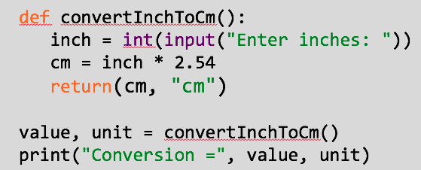

1. **Parameter Passing**

Write a program that will ask for the radius of a circle and then calculate and display that circle’s circumference (2 x 3.14 x radius) and that circle’s area (2 x 3.14 x 3.14).

The program should be made up of 4 subroutines – getRadius(), calculateCircumference(), calculateArea() and displayResults().

You should make sure that you pass parameters where necessary to make the program work fully.

**4.** Write similar programs for calculating the volume and total surface area of a cuboid, triangular prism and closed cylinder – using decomposition to identify separate subroutines and make sure to use parameter passing.